**Project Design Phase-II**

**Data Flow Diagram & User Stories**

|  |  |
| --- | --- |
| Date | 03 November 2023 |
| Team ID | NM2023TMID04574 |
| Project Name | How to Create a Reel Design Using Canva |

**Data Flow Diagrams:**

A Data Flow Diagram (DFD) is a traditional visual representation of the information flows within a system. A neat and clear DFD can depict the right amount of the system requirement graphically. It shows how data enters and leaves the system, what changes the information, and where data is stored.

**Example:** [**(Simplified)**](https://developer.ibm.com/patterns/visualize-unstructured-text/) **Example: Data Flow Diagram**

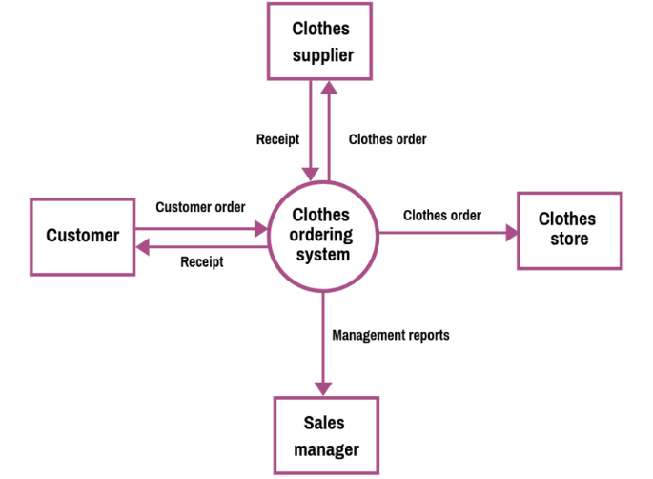 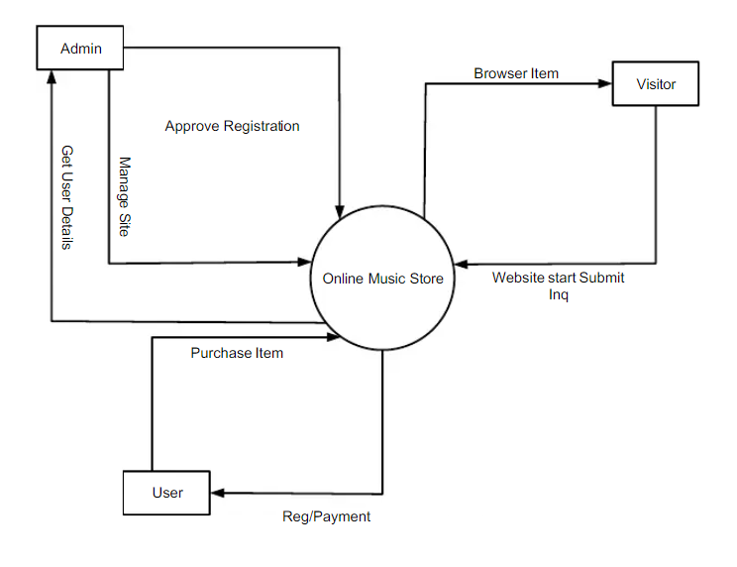

**User Stories**

By the below template to list all the user stories for the product.

| **User Type** | **Functional Requirement (Epic)** | **User Story Number** | **User Story / Task** | **Acceptance criteria** | **Priority** | **Team Member** |
| --- | --- | --- | --- | --- | --- | --- |
| Subscriber (Mobile user) | FR-001: Reel Creation Tool | USN-001 | As a marketing team member, I want to create a new marketing reel so I can showcase our products and services effectively. | I can access the marketing reel creation tool. | High | Oviyaa |
|  | FR-002: Media Upload | USN-002 | As a user, I want to be able to upload video clips and images to use in the marketing reel. | I can select and upload video clips and images. | High | Kaneetha |
|  | FR-003: Content Editing | USN-003 | As a user, I want to arrange and edit the order of video clips and images in the marketing reel. | I can drag and drop to arrange the sequence. | High | Vanamalar |
|  | FR-004: Text Overlay | USN-004 | As a user, I want to add captions and text overlays to the marketing reel. | I can add text and customize its appearance. | High | Oviyaa |
|  | FR-005: Background Music | USN-005 | As a user, I want to select background music for the marketing reel. | I can choose from a library of background music. | High | Jenifer |
| Subscriber (Web user) |  | SU-001 | As a subscriber, I want to create marketing reels using the online tool for sharing content and promotions with my network. | I can access the marketing reel creation tool from my subscriber account. | High | Kaneetha |
| Customer Care Executive |  | CC-001 | As a customer care executive, I want to assist subscribers in using the marketing reel tool, provide support, and troubleshoot issues. | I can access the subscriber's marketing reel project to assist with troubleshooting. | High | Vanamalar |
| Administrator |  | ADM-001 | As an administrator, I want to manage user access to the marketing reel tool and set user roles and permissions. | I can add, modify, and remove user accounts and assign roles. | High | Jenifer |